**The following is my proposition to the solution for Assignment #2:**

I’ll use the body of the 10_time_measurement kernel file. We need to do the following:

1. **Sum three arrays (add one array to all previous functions). Size is 2^22 this time.**
2. **Use error handling mechanisms (I’ll use it from 9_error_checking kernel)**
3. **Use timing measuring mechanisms (I’ll use it from 10_time_measurement kernel)**
4. **Measure the execution time of the GPU Implementation (same previous file)**
5. **Extra: Create a table of block sizes and see which one gives the best results (Test at least 5 times)**

I. The addition of the arrays is pretty much straight forward. Add another pointer argument in the kernel and in the CPU function, initialize a new array for both host and device, and add necessary arguments to the kernel initialization:

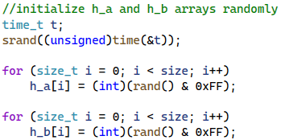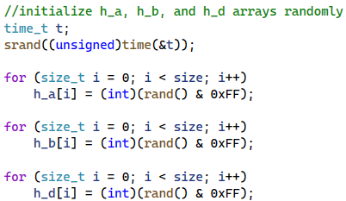



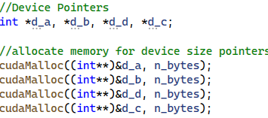



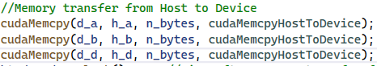



II. **The error handling will follow the same method of the error lesson. We will use macro to handle errors.**

*Note: In my testing, the code bellow always give the following error 🡪*

***Here’s how we solve it: (PD: This was solved too with the 10_time_measurement)***

**III. The timing measurements will be implemented from the 10_time_measurement**

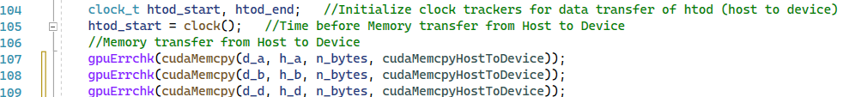kernel. It will contain the same commands in the same locations as the original one.

**IV. The execution time will be implemented as in the 10_time_measurement kernel.**

Here are the results for values 64, 128, 256 and 512:



***V. Because of the previous, the best Block Size for this kernel will be 128.***